Using this structure I got the basic premise of the while loop having the int called out and the while loop looking at while if statements and while do loops as well as this looking at functions as well and how to incorporate them.

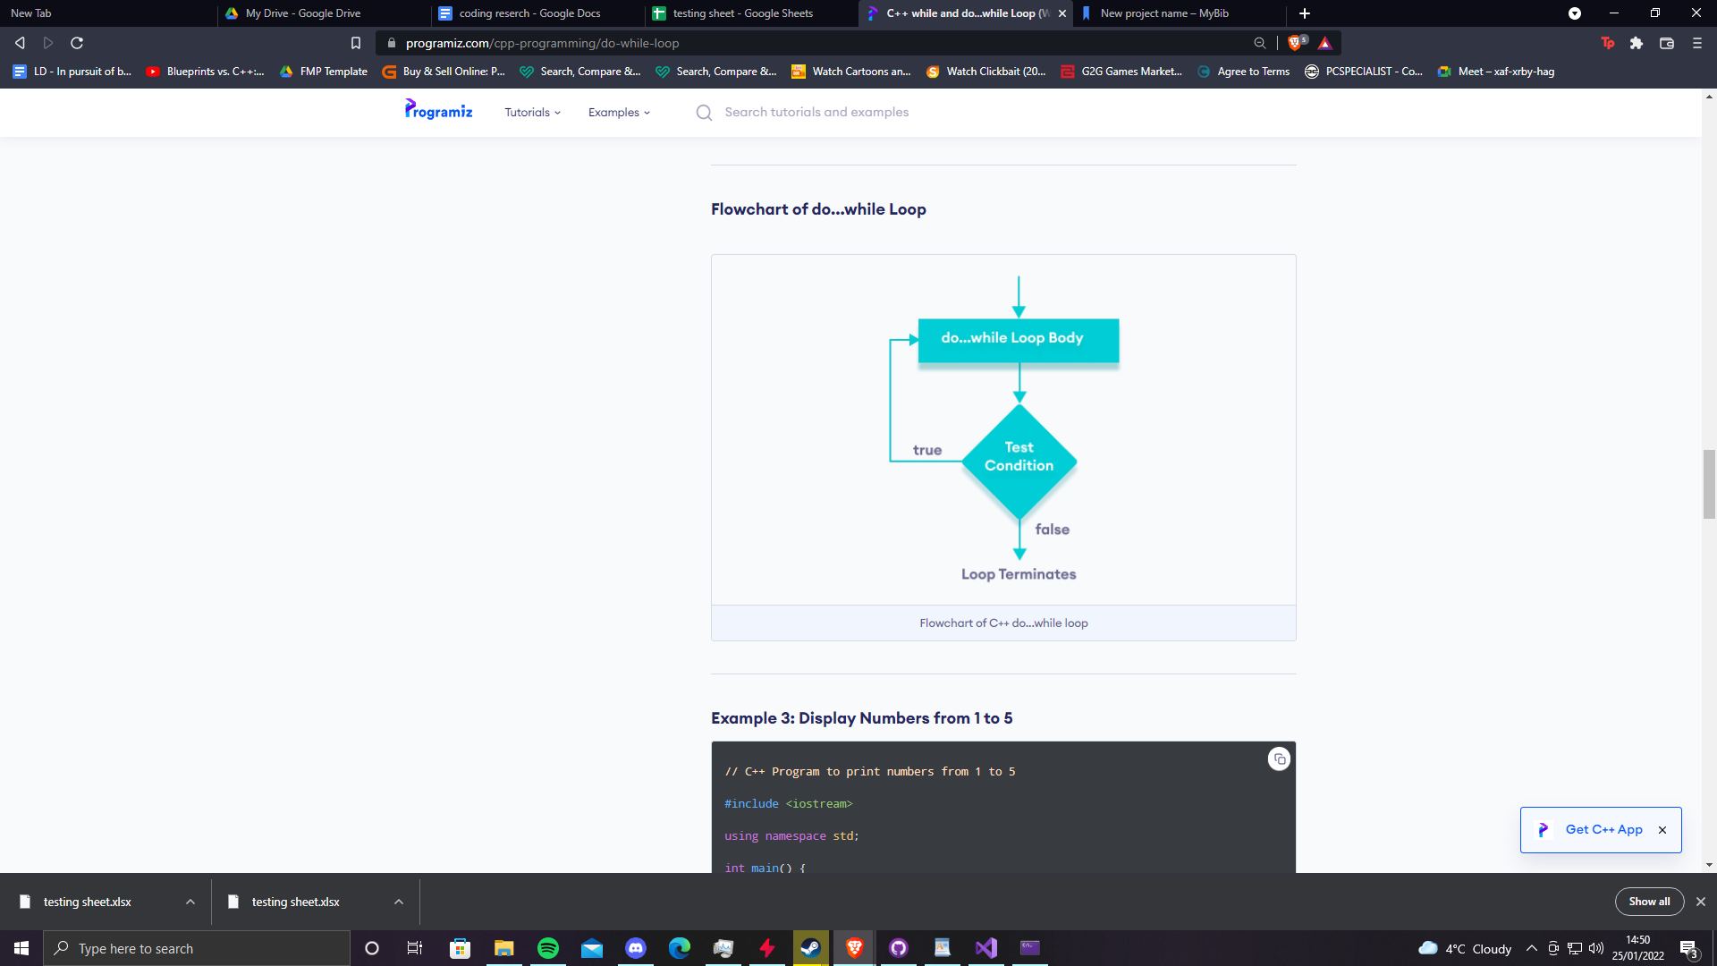

(programiz)

Doing research in to different functions as well asa how they worked as a refresher looking at the structure as well as variables to have a refresher on how they work and can allow me to show more frequently in my work

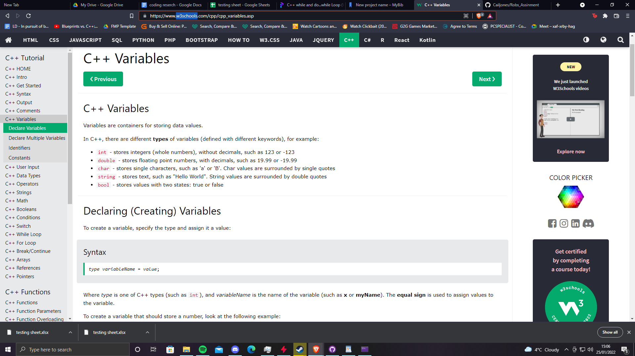

Plan

The plan will be to make a simple adventure game where the player has options to do something or something else inevitably having to face a boss at the end and quitting adventuring for good, so loops will be the main things i will be using as well as while loops and maybe even bools.

Reference list

programiz. “C++ While and Do...While Loop with Examples.” *Programiz.com*, 2019, www.programiz.com/cpp-programming/do-while-loop.

w3schools. “C++ Functions.” *Www.w3schools.com*, www.w3schools.com/cpp/cpp_functions.asp. Accessed 25 Jan. 2022.

w3schools. “C++ Variables.” *W3schools.com*, 2020, www.w3schools.com/cpp/cpp_variables.asp.